Marketing with Social Media
Lesson Plan
Learn how to use free online social media sites to market anything- a service, a product, an idea, an event or a person.

Lesson Objectives
Students will understand:
- the scope of social media tools available to them, and their differences
- how to grow their online audience
- how to increase engagement among their online audience
- how to start defining their online “brand identity”

Lesson Prep Work
(30 min, at a minimum, prior to student arrival)
- Log into accounts
  - Twitter username: CtcDPL email: ctcdpl@gmail.com password:
  - Carmella Friend Facebook: ctc@denverlibrary.org password:

Lesson Outline
The lesson is completed in one 90 minute class session.
- Introductions
  - Teacher introduces self, brief marketing history
  - Students introduce themselves, explain what it is they’re trying to market.
- Activities
  - 1. Your Social Media Tools
    - Define Social Media (any online site where human beings create accounts and interact with each other)
    - Watch Social Media Video 2013 http://www.youtube.com/watch?v=QUCfFcchw1w
      - Discuss: what sticks out at you about this video, in relation to your marketing goals?
        - 90% consumers trust peer review, 14% trust advertisements
        - In the future, consumers will not go find products. Products will find them via SM.
    - Do brief tour of popular SM sites, pointing out uniqueness and cross-SM similarities where appropriate:
      - Facebook – the biggest, most important SM site for marketing
        - Newsfeed=how news gets to users; all posts by people & businesses in their network will appear in their newsfeed.
        - Visual saturation – images, thumbnails on links and videos – media rich experience
        - 1 billion users = 1/7th of the planet
      - Twitter – more superficial, lends itself to pithiness (can be a good thing)
        - No visual candy, limit to 140 characters per post, links to pics and sites
        - Eg: sweet action ice cream (lots of followers, consistent format of posts)
      - YouTube – SM platform, but more importantly, a host for storing videos online so you can post the links elsewhere.
        - Eg: fashion denver channel – Do what you love, love what you do.
      - Website/Blog – not SM per say, but can be an important part of establishing yourself online.
        - Plug Wordpress classes
        - Eg: Fancy Tiger crafts blog – tons of pictures, op-ed about their topic, links to videos hosted on YouTube
      - Yelp – super important for anyone with tangible things to market (service or product)
        - Local reviews by actual human beings, trusted by actual human beings
        - Activity: have students do a search for businesses in their category.
  - 2. How your SM tools work together
    - Draw image on board (1 color for SM, 2nd color for print/old fashioned marketing tools)
      - Creating traffic from all online sites to SM/online sites
      - Funneling real-world traffic into SM
      - Goal: create a wind tunnel of engagement where your customers/audience are engaging with you in more and more places.
      - 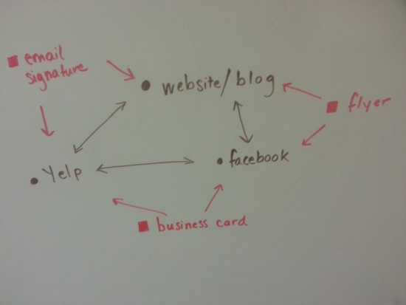
  - 3. Increase Your Audience via Engagement (aka Fans/Followers/Likes)
    - Draw image on board (different colors for each circle). Star = You. Model reflects much smaller numbers than reality b/c math is easier when multiplying by 100.
      - 1st circle= your Fans- they will see what you post in their newsfeed
      - 2nd circle= Friends of Fans. They will only see what you post when your Fan engages with your post.
        - Write on board: Engagement=Like, Comment, Share, Click
        - Arrow from one circle to the other = Engagement. The only way to reach people you aren’t already reaching is to get Engagement from your audience.
        - Growing your audience is the purpose of marketing, and you’ll only do that by engaging with your SM audience.
      - This is the Facebook model, but all SM function more or less like this.
        - 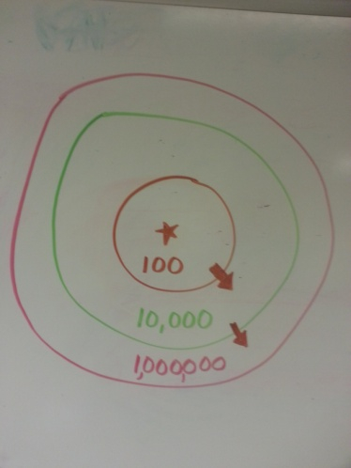
    - How to make posts with high chances of Engagement
      - Draw image on board
        - Eye = eye candy. Humans like looking at stuff. Posts with image get 2x as much play.
          - Ask: can anyone give me an example of an image that would be good for what they’re marketing?
        - Heart = emotions. Find the emotional appeal in what you’re marketing.
          - Ask: can anyone give me an example of how they could appeal to people’s emotions?
          - Tip: Give a behind-the-scenes view of your business. Personal stories of your workers/yourself/your equipment/etc.
            - Everyone wants to be the guy who says “I’ll have the usual” at a restaurant. Giving behind-the-scenes view makes your audience feel that they “know” you. Increase rapport=increase business.
        - Brain = Intellect. Humans like to be smart. Teach ‘em something about what it is you’re marketing.
        - 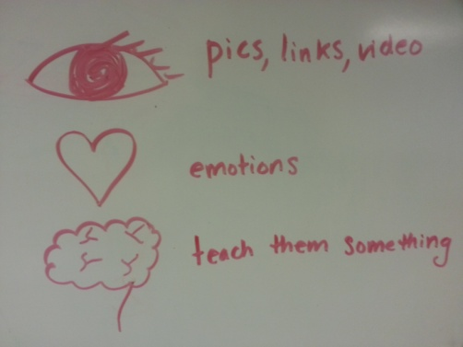
      - Always stay upbeat- negativity, even if it’s an important message, bombs on SM.
      - Time your posts for your audience
        - Peak SM time is M-F 9-5. Posting late-morning to early-afternoon on weekdays is a good place to start.
          - Specific audiences vary, so monitor what times of day seem to be the best for you. Eg: teachers can’t SM during work hours, but office workers can and do.

  - 4. Making a Social Media Plan
    - Ack! All of this can seem overwhelming. How will you have time to do your actual work plus do social media?
    - Social Media Plan Worksheet – go through it item by item
      - Note: the point of this is to create a sustainable plan of action- don’t just jump in and then sink, but find a way to make it work for you.
      - 1. Content & Responses
        - When/how long/how frequently is it realistic for you to be SMing?
      - 2. Admins & Helpers
        - Do you have anyone who could help you manage all this- any employee, a friend, a spouse, a family member?
        - If anyone besides you is admining the site, make sure to only give them the privileges that they need.
          - Pull up FB admin chart: http://www.facebook.com/help/289207354498410?q=what%20is%20a%20content%20creator%3F&sid=07LFEWi4SdDZTXxZD
          - Note: this is for FB, but all SM sites have some sort of compartmentalized admin privileges you can set.
          - Suggestion: only yourself, someone you really really trust (and who is tech savvy) should maintain highest rights.
  - 5. Your Brand Voice (final page of worksheet)
    - Thought Activity: if you had to create a character who was Mr./Ms. Your Brand, who would that character be?
      - See if any student is willing to do this out loud with you.
      - Age? Financial Status? What do they do outside of your brand? What do they care about?
      - What do they dress like- what’s their aesthetic? What do they talk like? What turns them off?
      - Try and pinpoint as many adjectives as you can to describe your audience.
    - Once you’ve pinpointed who your audience is, you need craft your marketing towards them.
      - Write in language they use/like. Use the aesthetic that appeals to them. Teach them things they’ll find interesting. Appeal to their unique emotions.
      - This is your Brand Voice.
    - Make your Brand Voice unified across all your SM platforms.
      - Have the tone of your videos match the tone of your posts. Have your blog match that tone.

